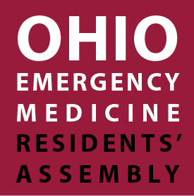
DISCOVER.
August 14, 2014
EXPERIENCE.
PURSUE.
9 – 9:45 am Registration, Networking & Breakfast
        - Network with Exhibitors and Sponsors
        - Poster Competition & Judging

9:45 – 9:55 am Welcome from Ohio ACEP – John Lyman, MD, FACEP and
Michael McCrea, MD, FACEP
9:55 – 10:05 am Welcome from ACEP – Alex Rosenau, DO, FACEP

10:05 – 11:30 am Life After Residency: Practice Options Panel
        - Catherine Marco, MD, FACEP (Panel Moderator)
        - Jim Augustine, MD, FACEP
        - Eileen Baker, MD, FACEP
        - Dan Breece, DO, FACEP
        - Rita Cydulka, MD, FACEP
        - Alex Rosenau, DO, FACEP
        - John Tafuri, MD

11:30 am – 12 pm Morning Networking Break
        - Career Fair & Visit Exhibitors
        - Poster Competition & Judging

12 – 1:15 pm Luncheon
Leadership Opportunities at ACEP – Mark DeBard, MD, FACEP
        - Exhibitor Spotlight
        - Election of Resident Board of Directors Member

1:15 – 2:45 pm EMRA Update & Quiz Show
        - Jordan Celeste, MD
        - Matt Rudy, MD
        - Cameron Decker, MD

2:45 – 3:05 pm Afternoon Networking Break
        - Career Fair & Visit Exhibitors

3:05 – 4:30 pm High Risk Emergency Medicine! – Kevin Klauer, DO, EJD, FACEP

4:30 pm Announcements & Closing Comments – John Lyman, MD, FACEP
        - Poster Competition Winner!
        - Door Prizes and Drawing Winners
        - ADVOCACY. EDUCATION. LEADERSHIP.
www.ohacep.org/residentsassembly

