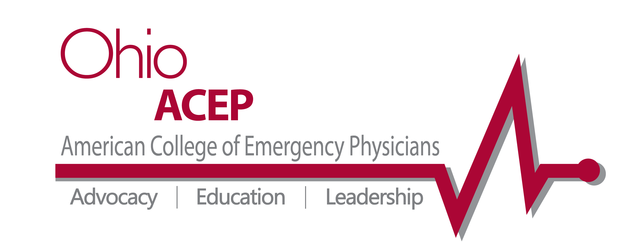

Date: June 7, 2013

Dr. Thomas Hetrick Named 2013 Emergency Medicine Physician of the Year at Ohio ACEP Annual Meeting

Columbus, OH—On June 4 at its Annual Meeting, Ohio ACEP presented the 2013 Emergency Medicine Physician of the Year Award to an outstanding physician whose tireless work as an educator has touched countless EM students over his career. The 2013 Emergency Medicine Physician of the Year is Thomas Hetrick, MD, FACEP.

The Emergency Medicine Physician of the Year Award is presented annually to an exceptional physician who encourages members to pursue the ideals of emergency medicine. The Award is designed to recognize demonstrated excellence in clinical practice, mentoring other physicians and active contributions to their communities through service and education.

Over the course of his impressive career, Dr. Thomas Hetrick has exemplified these criteria. For over three decades, he has played an essential role in developing the next generation of emergency physicians at Akron General’s Emergency Medicine residency, the nation’s oldest community EM training program. He is one of the program’s original faculty members, which is currently celebrating 40 years of excellence in emergency medicine education.

Dr. Paul Been, who nominated Dr. Hetrick for the Emergency Medicine Physician of the Year Award said: “Having recently trained under this physician, I can confidently state that he played an integral role in my development as an emergency medicine physician; more than any other attending during residency, in fact.”

Congratulations to Dr. Thomas Hetrick for his well-deserved award!

###

Ohio ACEP is a state medical specialty society representing emergency medicine physicians with more than 1,200 members. For over 40 years, Ohio ACEP has served the state’s emergency physicians through tireless advocacy, nationally-recognized continuing medical education and physician leadership development.

###

