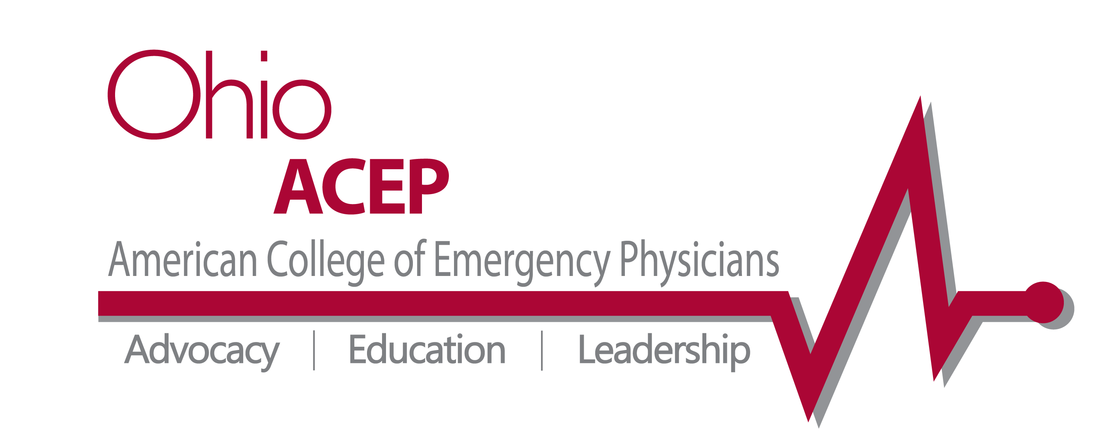

Date: June 7, 2013

Bill Hall Award Presented at Ohio ACEP Annual Meeting to
Dominic J. Bagnoli Jr. MD, FACEP

Dominic Bagnoli, MD, FACEP
Winner of the 2013 Bill Hall Award
Columbus, OH—On June 4 at its Annual Meeting, the Ohio Chapter, American College of Emergency Physicians (Ohio ACEP) awarded the 2013 Bill Hall Award for Service to a remarkable physician who has worked tirelessly on behalf of patients, his physician colleagues and the specialty of emergency medicine. This year, the Bill Hall Award for Service was presented to Dominic J. Bagnoli, MD, FACEP.

The Bill Hall Award for Service is the highest honor bestowed by Ohio Chapter ACEP. It is presented annually to a past or present member of the Chapter’s Board of Directors who reflects the character of Dr. William Hall as evidenced by the selfless giving of time and enthusiasm to the advancement of emergency medicine and patient care.

This year’s winner, Dr. Dominic Bagnoli, has been an ACEP member for over 20 years and has served the Ohio Chapter as a Board member, Councillor, Chapter Secretary and Chapter President. His leadership, both in the business of emergency medicine and in advocating for the specialty, has gained Dr. Bagnoli immense respect among his colleagues. In addition to being the single largest donor to Ohio ACEP’s political action committee, his leadership with the Chapter was instrumental in developing the capacity of the Ohio ACEP EM PAC, thus improving the Chapter’s ability to advocate for its members and paving the way for an increased role for the Chapter in health policy. His efforts as part of Ohio ACEP’s leadership have made an indelible mark on the Chapter and have undeniably moved the organization forward.

Congratulations to Dr. Dominic Bagnoli for his well-deserved award!

###

Ohio ACEP is a state medical specialty society representing emergency medicine physicians with more than 1,200 members. For over 40 years, Ohio ACEP has served the state’s emergency physicians through tireless advocacy, nationally-recognized continuing medical education and physician leadership development.

###

